# Department of Computing

**CS-213: Advanced Programming**

**Class: BSCS 7AB**

# Lab 06: Node.js MongoDB

**Date: 3rd October, 2019**

**Time: 10:00-01:00pm & 02:00-05:00pm**

***Submitted by: Muhammad Nouman Imran***

**(215192)**

# Instructor: Dr. Sidra Sultana

**Lab Engineer: Ms. Ayesha Asif**

# 

# Lab 06: Node.js MongoDB

**Introduction**

Node.js can be used in database applications. One of the most popular NoSQL database is MongoDB.

**Objectives**

This lab will get you familiar with the node.js MongoDB environment.

**Tools/Software Requirement**

Node.js, Notepad

**Helping Material**

Slides of Lecture 7

<https://www.w3schools.com/nodejs/nodejs_mongodb.asp>

**Lab Tasks**

***Note: The Mongo Db is giving the Node 12548 Deprecation Warning on each line of the command prompt execution which is because of the current version of the Mongo which says that the current URL string parser is deprecated. It asks to add the new parser which is not mandatory as the code is working properly without giving any error. This warning can be ignored.***

**Task 1:** Create a database named "mydb". Save the code in a file called "demo_create_mongo_db.js" and run the file.

**Code:**

var MongoClient = require('mongodb').MongoClient;

var url = "mongodb://localhost:27017/mydb";

MongoClient.connect(url, function(err, db) {

  if (err) throw err;

  console.log("Database created!");

  db.close();

});

**Output:**



**Task 2:** Create a collection called "customers". Save the code in a file called "demo_mongodb_createcollection.js" and run the file.

**Code:**

var MongoClient = require('mongodb').MongoClient;

var url = "mongodb://localhost:27017/";

MongoClient.connect(url, function(err, db) {

  if (err) throw err;

var dbo = db.db("mydb");

  dbo.createCollection("customers", function(err, res) {

    if (err) throw err;

    console.log("Collection created!");

    db.close();

  });

});

**Output:**

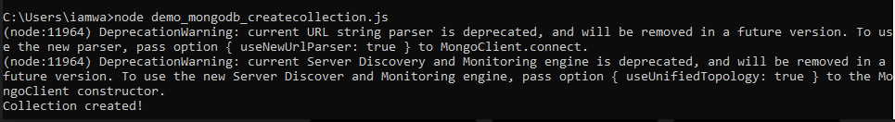

**Task 3:** Insert a document in the "customers" collection. Save the code in a file called "demo_mongodb_insert.js" and run the file.

**Code:**

var MongoClient = require('mongodb').MongoClient;

var url = "mongodb://localhost:27017/";

MongoClient.connect(url, function(err, db) {

if (err) throw err;

var dbo = db.db("mydb");

var myobj = { name: "Company Inc", address: "Highway 37" };

dbo.collection("customers").insertOne(myobj, function(err, res) {

if (err) throw err;

console.log("1 document inserted");

db.close();

});

});

**Output:**

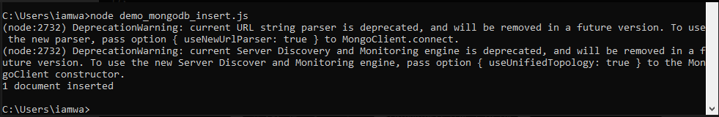

**Task 4:** Insert multiple documents in the "customers" collection. Save the code in a file called "demo_mongodb_insert_multiple.js" and run the file.

**Code:**

var MongoClient = require('mongodb').MongoClient;

var url = "mongodb://localhost:27017/";

MongoClient.connect(url, function(err, db) {

if (err) throw err;

var dbo = db.db("mydb");

var myobj = [

{ name: 'John', address: 'Highway 71'},

{ name: 'Peter', address: 'Lowstreet 4'},

{ name: 'Amy', address: 'Apple set 652'},

{ name: 'Hannah', address: 'Mountain 21'},

{ name: 'Michael', address: 'Valley 345'},

{ name: 'Sandy', address: 'Ocean blvd 2'},

{ name: 'Betty', address: 'Green Grass 1'},

{ name: 'Richard', address: 'Sky st 331'},

{ name: 'Susan', address: 'One way 98'},

{ name: 'Vicky', address: 'Yellow Garden 2'},

{ name: 'Ben', address: 'Park Lane 38'},

{ name: 'William', address: 'Central st 954'},

{ name: 'Chuck', address: 'Main Road 989'},

{ name: 'Viola', address: 'Sideway 1633'}

];

dbo.collection("customers").insertMany(myobj, function(err, res) {

if (err) throw err;

console.log("Number of documents inserted: " + res.insertedCount);

db.close();

});

});

**Output:**

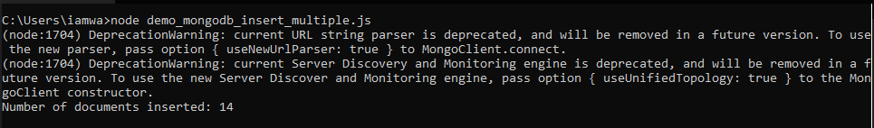

**Task 5:** Insert three records in a "products" table, with specified _id fields. Save the code in a file called "demo_mongodb_insert_id.js" and run the file.

**Code:**

var MongoClient = require('mongodb').MongoClient;

var url = "mongodb://localhost:27017/mydb";

MongoClient.connect(url, function(err, db) {

if (err) throw err;

var dbo = db.db("mydb");

var myobj = [

{ _id: 154, name: 'Chocolate Heaven'},

{ _id: 155, name: 'Tasty Lemon'},

{ _id: 156, name: 'Vanilla Dream'}

];

dbo.collection("products").insertMany(myobj, function(err, res) {

if (err) throw err;

console.log(res);

db.close();

});

});

**Output:**

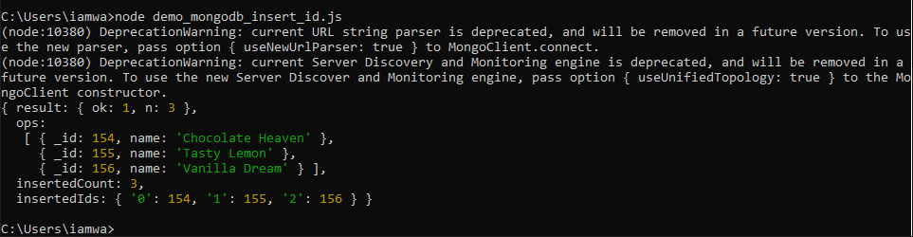

**Task 6:** Find the first document in the customer’s collection. Save the code in a file called "demo_mongodb_findone.js" and run the file.

**Code:**

var MongoClient = require('mongodb').MongoClient;

var url = "mongodb://localhost:27017/";

MongoClient.connect(url, function(err, db) {

if (err) throw err;

var dbo = db.db("mydb");

dbo.collection("customers").findOne({}, function(err, result) {

if (err) throw err;

console.log(result.name);

db.close();

});

});

**Output:**

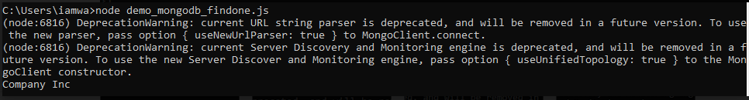

**Task 7:** Return the fields "name" and "address" of all documents in the customers collection

**Code:**

var MongoClient = require('mongodb').MongoClient;

var url = "mongodb://localhost:27017/";

MongoClient.connect(url, function(err, db) {

if (err) throw err;

var dbo = db.db("mydb");

dbo.collection("customers").find({}, { projection: { _id: 0, name: 1, address: 1 } }).toArray(function(err, result) {

if (err) throw err;

console.log(result);

db.close();

});

});

**Output:**

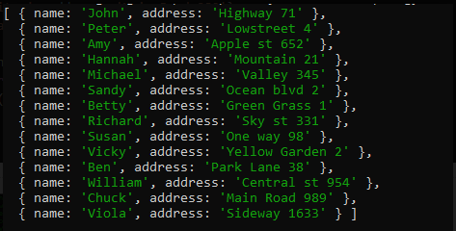

**Task 8:** Find documents with the address "Park Lane 38". Save the code in a file called "demo_mongodb_query.js" and run the file.

**Code:**

var MongoClient = require('mongodb').MongoClient;

var url = "mongodb://localhost:27017/";

MongoClient.connect(url, function(err, db) {

if (err) throw err;

var dbo = db.db("mydb");

/*Return only the documents with the address "Park Lane 38":*/

var query = { address: "Park Lane 38" };

dbo.collection("customers").find(query).toArray(function(err, result) {

if (err) throw err;

console.log(result);

db.close();

});

});

**Output:**

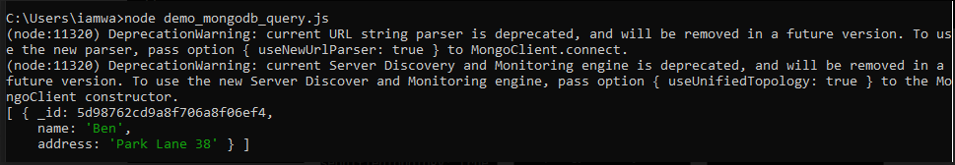

**Task 9:** Sort the result alphabetically by name. Save the code in a file called "demo_sort.js" and run the file.

**Code:**

var MongoClient = require('mongodb').MongoClient;

var url = "mongodb://localhost:27017/";

MongoClient.connect(url, function(err, db) {

if (err) throw err;

var dbo = db.db("mydb");

//Sort the result by name:

var sort = { name: 1 };

dbo.collection("customers").find().sort(sort).toArray(function(err, result) {

if (err) throw err;

console.log(result);

db.close();

});

});

**Output:**

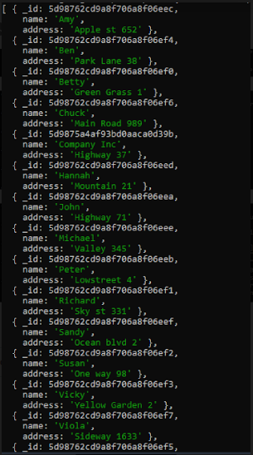

**Task 10:** Delete the document with the address "Mountain 21". Save the code in a file called "demo_delete.js" and run the file.

**Code:**

var MongoClient = require('mongodb').MongoClient;

var url = "mongodb://localhost:27017/";

MongoClient.connect(url, function(err, db) {

if (err) throw err;

var dbo = db.db("mydb");

/*Delete the first customers with the address "Mountain 21":*/

var myquery = { address: 'Mountain 21' };

dbo.collection("customers").deleteOne(myquery, function(err, obj) {

if (err) throw err;

console.log("1 document deleted");

db.close();

});

});

**Output:**

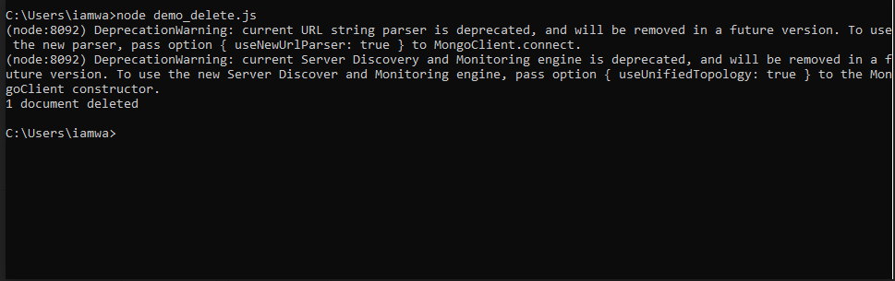

**Task 11:** Delete all documents were the address starts with the letter "O". Save the code in a file called "demo_delete_many.js" and run the file

**Code:**

var MongoClient = require('mongodb').MongoClient;

var url = "mongodb://localhost:27017/";

MongoClient.connect(url, function(err, db) {

if (err) throw err;

var dbo = db.db("mydb");

var myquery = { address: /^O/ };

dbo.collection("customers").deleteMany(myquery, function(err, obj) {

if (err) throw err;

console.log(obj.result.n + " document(s) deleted");

db.close();

});

});

**Output:**

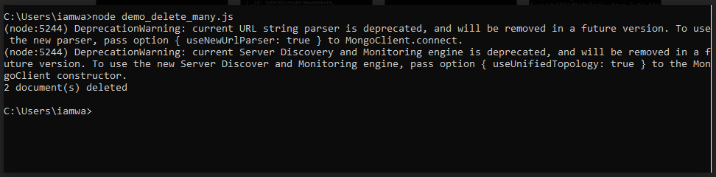

**Task 12:** Delete the "customers" table. Save the code in a file called "demo_drop.js" and run the file.

**Code:**

var MongoClient = require('mongodb').MongoClient;

var url = "mongodb://localhost:27017/";

MongoClient.connect(url, function(err, db) {

if (err) throw err;

var dbo = db.db("mydb");

dbo.collection("customers").drop(function(err, delOK) {

if (err) throw err;

if (delOK) console.log("Collection deleted");

db.close();

});

});

**Output:**



**Task 13:** Update the document with the address "Valley 345" to name="Mickey" and address="Canyon 123". Save the code in a file called "demo_update_one.js" and run the file

**Code:**

var MongoClient = require('mongodb').MongoClient;

var url = "mongodb://localhost:27017/";

MongoClient.connect(url, function(err, db) {

if (err) throw err;

var dbo = db.db("mydb");

var myquery = { address: "Valley 345" };

var newvalues = { $set: { name: "Michael", address: "Canyon 123" } };

dbo.collection("customers").updateOne(myquery, newvalues, function(err, res) {

if (err) throw err;

console.log("1 document updated");

db.close();

});

});

**Output:**

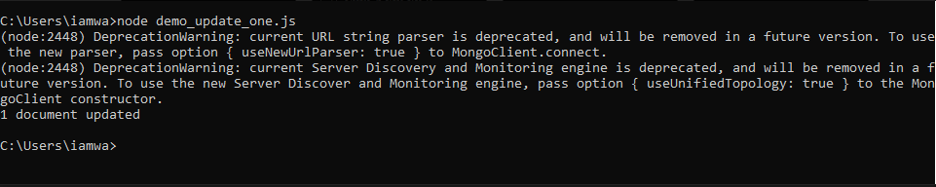

**Task 14:** Consider you have a "customers" collection. Limit the result to only return 5 documents. Save the code above in a file called "demo_mongodb_limit.js" and run the file.

**Code:**

var MongoClient = require('mongodb').MongoClient;

var url = "mongodb://localhost:27017/";

MongoClient.connect(url, function(err, db) {

if (err) throw err;

var dbo = db.db("mydb");

dbo.collection("customers").find().limit(5).toArray(function(err, result) {

if (err) throw err;

console.log(result);

db.close();

});

});

**Output:**

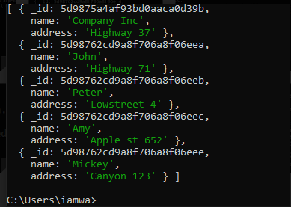

**Task 15:** Practice the Join operations on different tables.

**Products Table:**

var MongoClient = require('mongodb').MongoClient;

var url = "mongodb://localhost:27017/";

MongoClient.connect(url, function(err, db) {

if (err) throw err;

var dbo = db.db("mydb");

var myobj = [

{ name: 'apple ipad', address: 'Highway 71'},

{ name: 'Iphone', address: 'Lowstreet 4'},

{ name: 'bat', address: 'Apple st 652'},

{ name: 's6 tab', address: 'Mountain 21'},

{ name: 'table', address: 'Valley 345'},

{ name: 'balls', address: 'Ocean blvd 2'},

{ name: 'Headphones', address: 'Green Grass 1'},

{ name: 'Reyzen headsets', address: 'Sky st 331'},

{ name: 'NETBALL', address: 'One way 98'},

{ name: 'Shoes', address: 'Yellow Garden 2'},

{ name: 'basketball', address: 'Park Lane 38'},

{ name: 'ChromeBook by Lenovo', address: 'Central st 954'},

{ name: 'guitar', address: 'Main Road 989'},

{ name: 'Huawei Y7 Prime', address: 'Sideway 1633'}

];

dbo.collection("products").insertMany(myobj, function(err, res) {

if (err) throw err;

console.log("Number of documents inserted: " + res.insertedCount);

db.close();

});

});

**Code:**

var MongoClient = require('mongodb').MongoClient;

var url = "mongodb://[127.0.0.1:27017/](http://127.0.0.1:27017/)";

MongoClient.connect(url, function(err, db) {

if (err) throw err;

var dbo = db.db("mydb");

dbo.collection('customers').aggregate([

{ $lookup:

{

from: 'products',

localField: 'name',

foreignField: 'name',

as: 'customersdetails'

}

}

]).toArray(function(err, res) {

if (err) throw err;

console.log(JSON.stringify(res));

db.close();

});

});

**Output:**

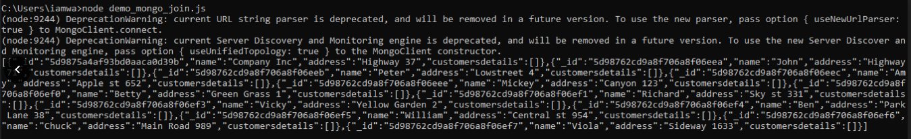

### Deliverables

Compile a single word document by filling in the solution part and submit this Word file on LMS. This lab grading policy is as follows: The lab is graded between 0 to 10 marks. The submitted solution can get a maximum of 5 marks. At the end of each lab or in the next lab, there will be a viva related to the tasks. The viva has a weightage of 5 marks. Insert the solution/answer in this document. You must show the implementation of the tasks in the designing tool, along with your complete Word document to get your work graded. You must also submit this Word document on the LMS. In case of any problems with submissions on LMS, submit your Lab assignments by emailing it to Ms. Ayesha Asif: [ayesha.asif@seecs.edu.pk](mailto:ayesha.asif@seecs.edu.pk).